The following are examples of the 136 images from 15 middle schools that were presented for two weeks at the Pepco Edison Place Gallery in Washington, DC as part of the 3rd annual district-wide Everyday DC exhibition. The images were taken as a result of a multi-week photojournalism unit supported by Pulitzer Center and the visual arts team at DC Public Schools. Here are blog posts highlighting more examples from the 2018 and 2017 exhibitions.

- Maxwell School
Dump Truck
“A dump truck in an alley backing up.”-November 30, 2018
Oyster-Adams Bilingual School
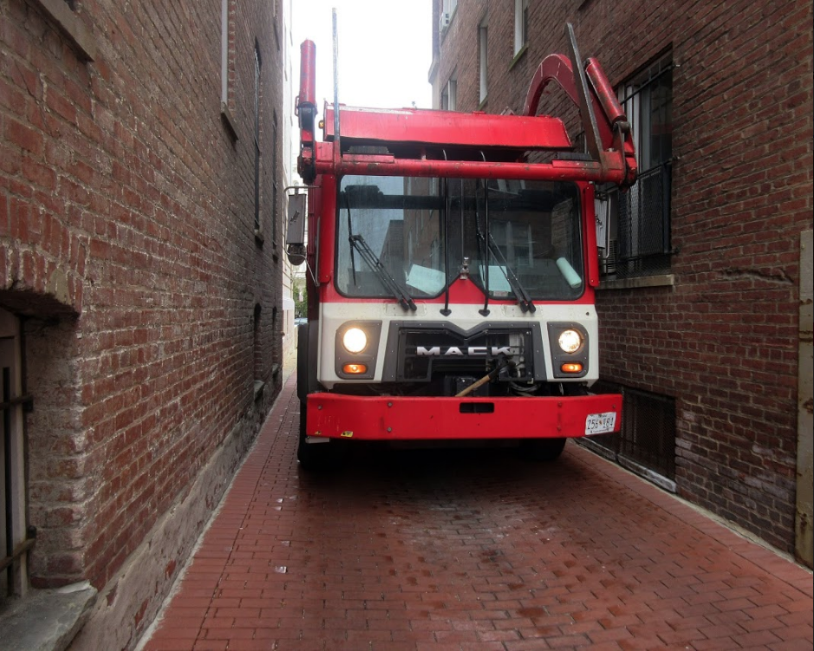

- McKenzie Haynes
Lonely Home
“These houses are getting torn down and these are the last on our block.”
Excel Academy
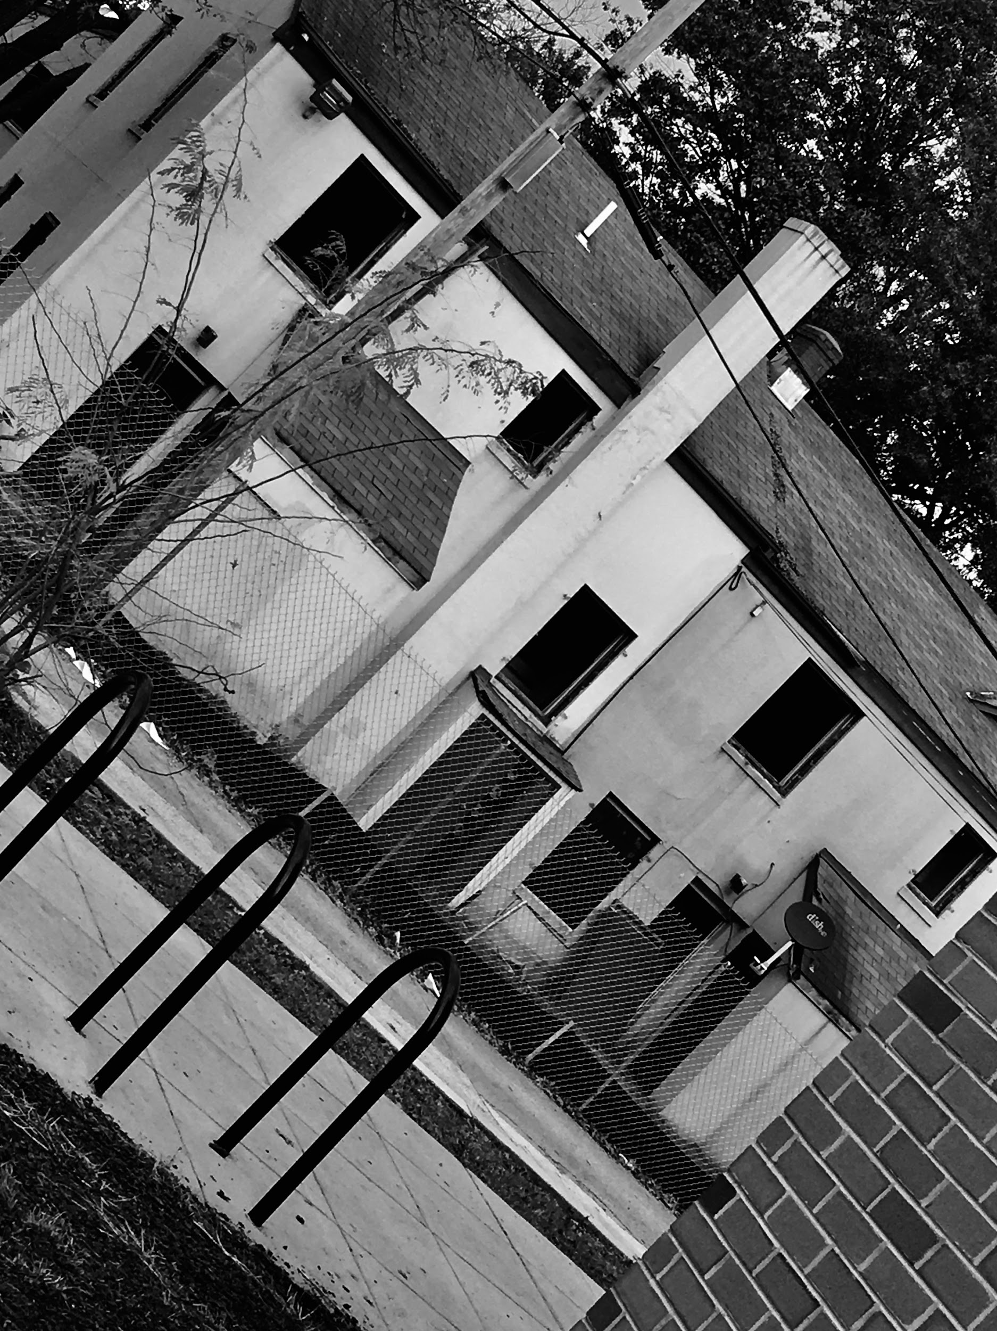
- Phillip Crowell
As Close As Me
“No one could get as close as me to the Ducks at the Duck Pond, I laid down, and waited for the ducks calmly and quietly, until they all started to swim towards me. I'm King of the Ducks!”-October 2018
Jefferson Academy Middle School/
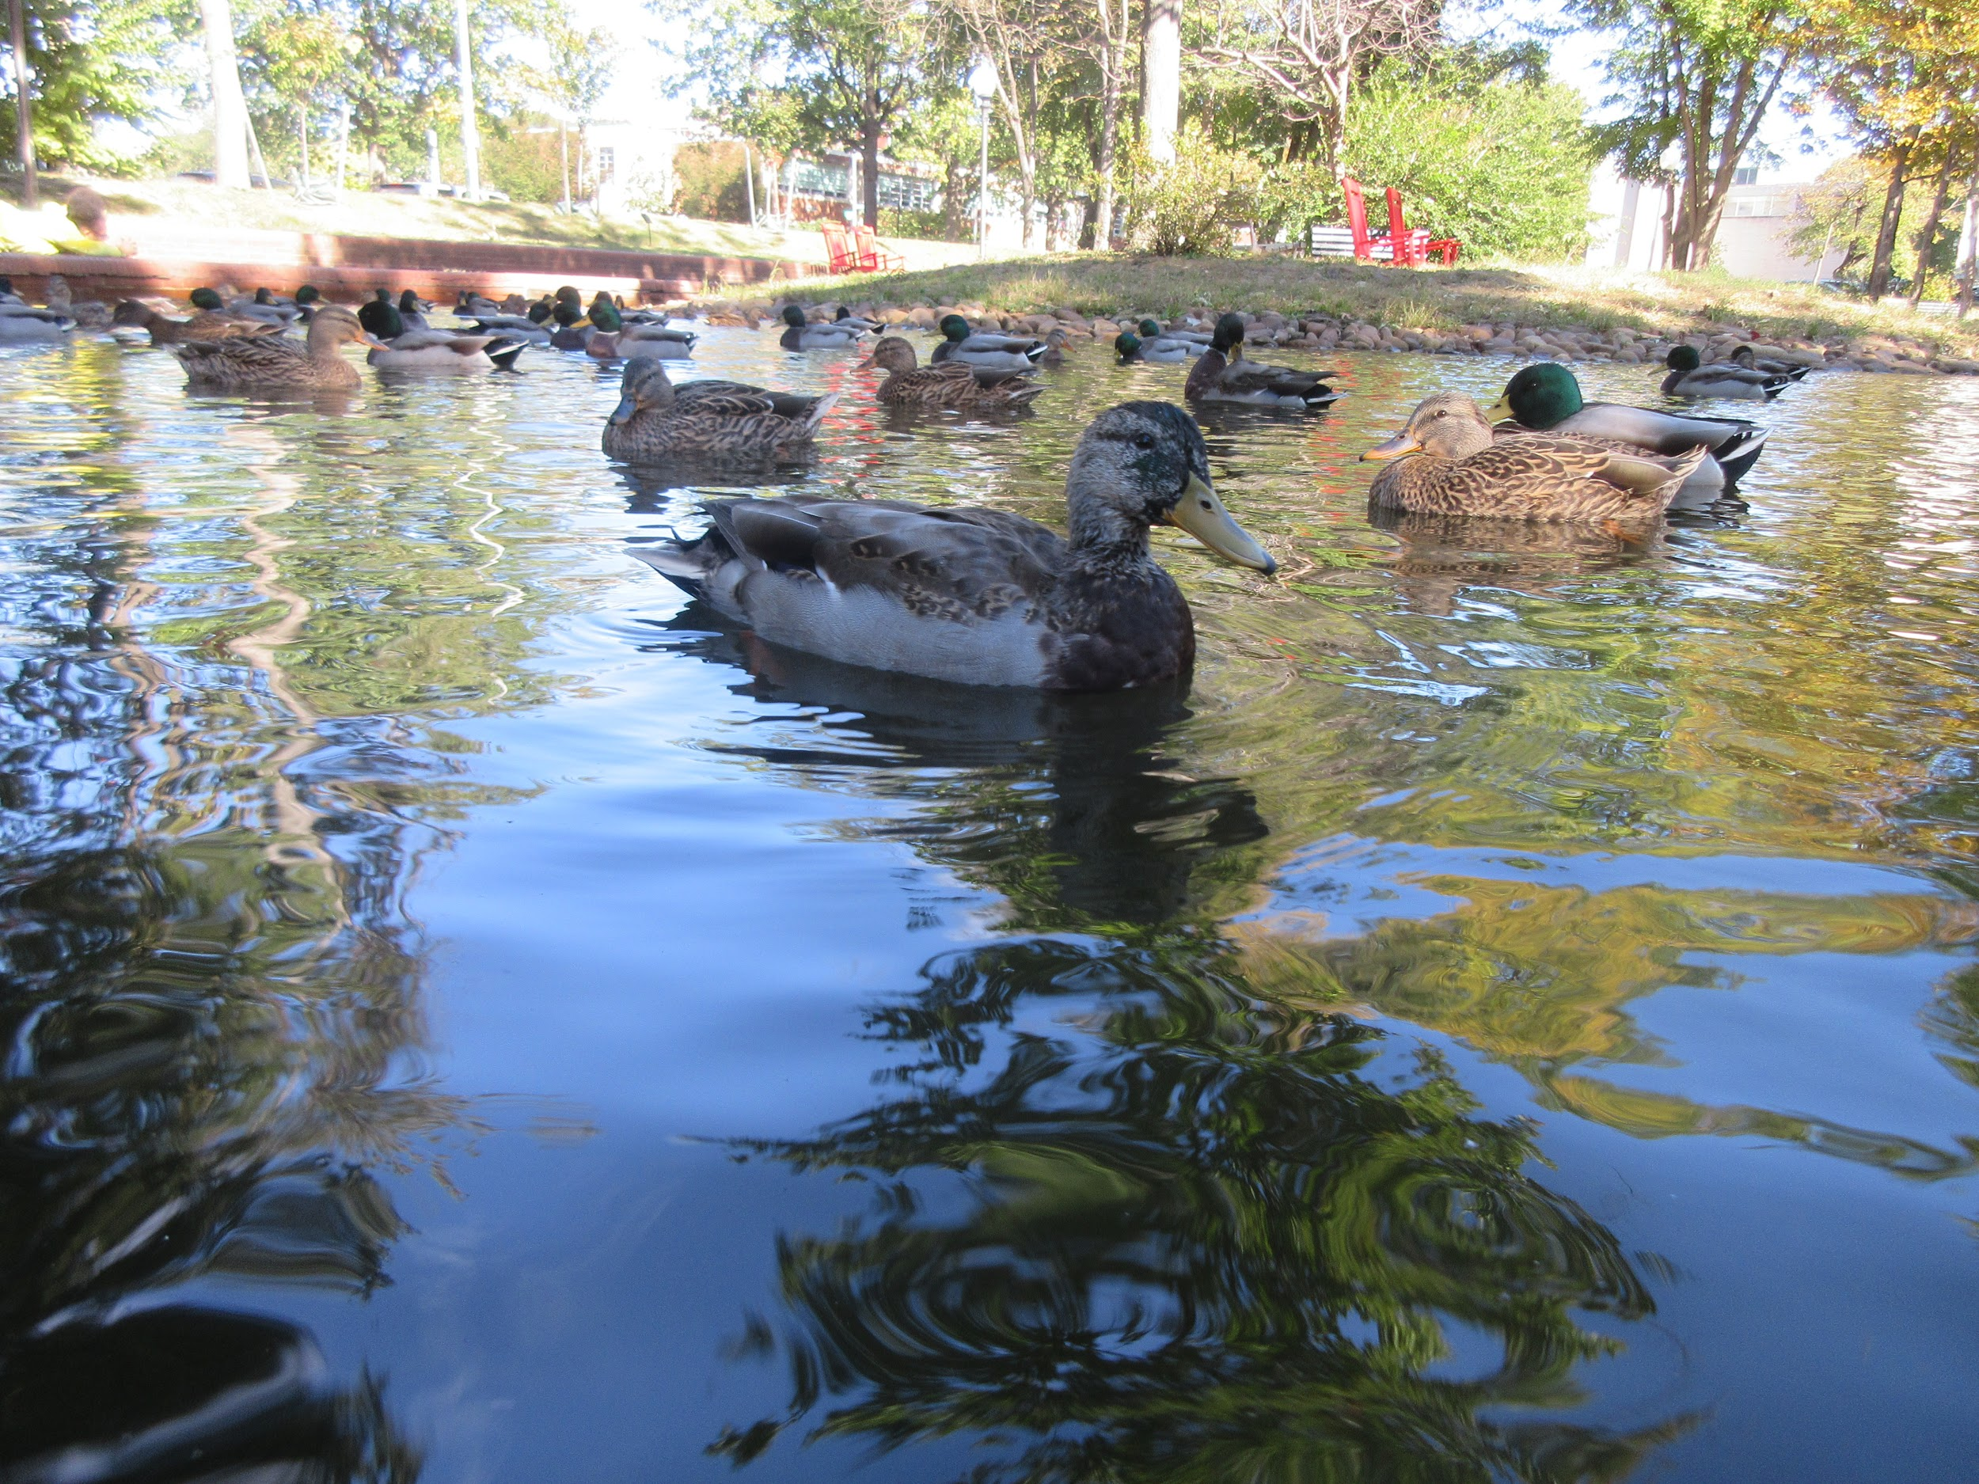

- Quinn McGovern
Felipe
“This is a boy lying on the field of Alice Deal Middle School to enjoy the last seconds of the summer sun.”-October 2018
Alice Deal Middle School
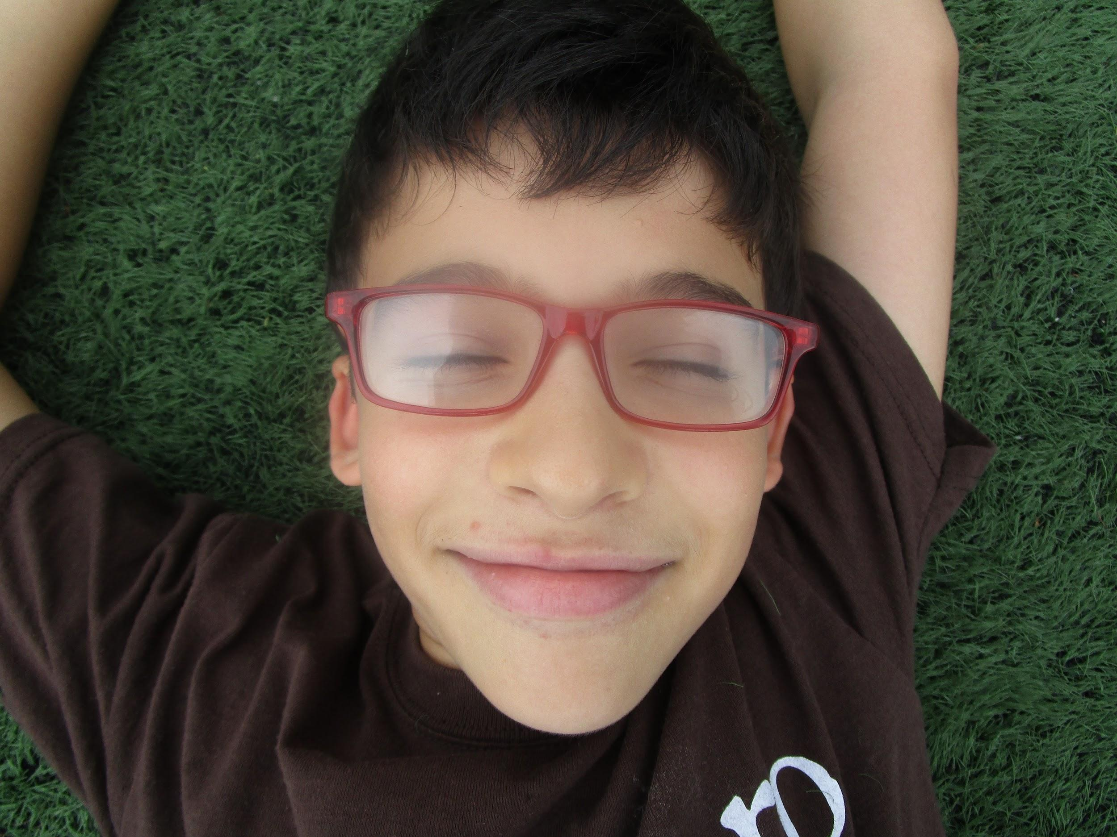

- Catie Guire
Rainbow
“Rain is not just gloomy.”-December 2018
Eliot-Hine Middle School
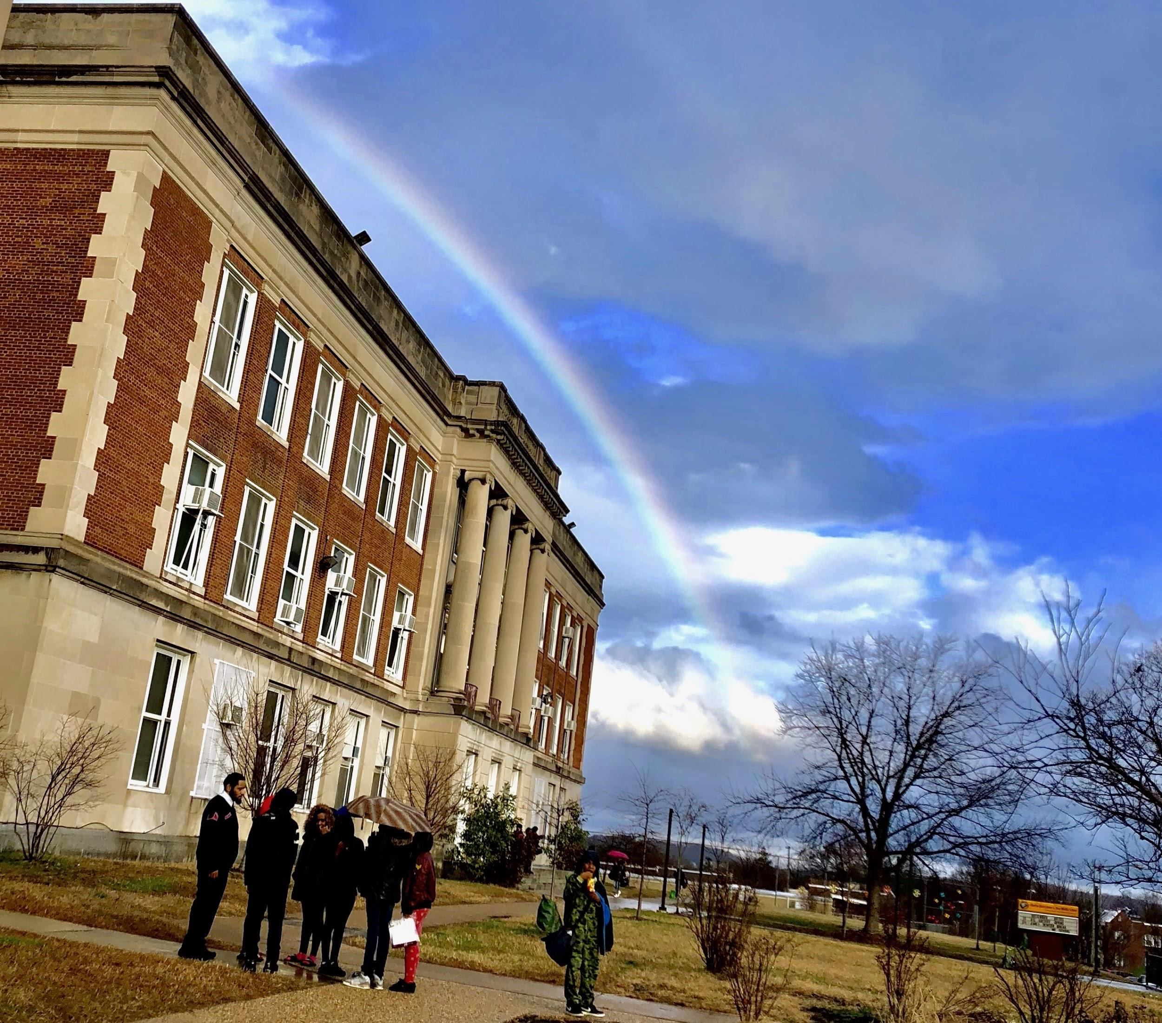

- Felix Ulmanu
My Father
“As my father and I walk uptown, I spot a neon sign in a shop window and I tell my dad to stop. We keep talking and in the moment, he laughs. I just click the shutter.”
Hardy Middle School
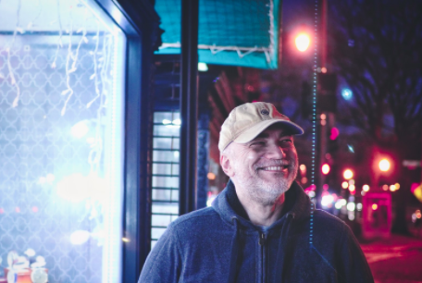

- Jennifer Romero and Alba Santos
Shadows
“This is a picture of Alba playing with shadows created from the window.”-December 19, 2018
MacFarland Middle School
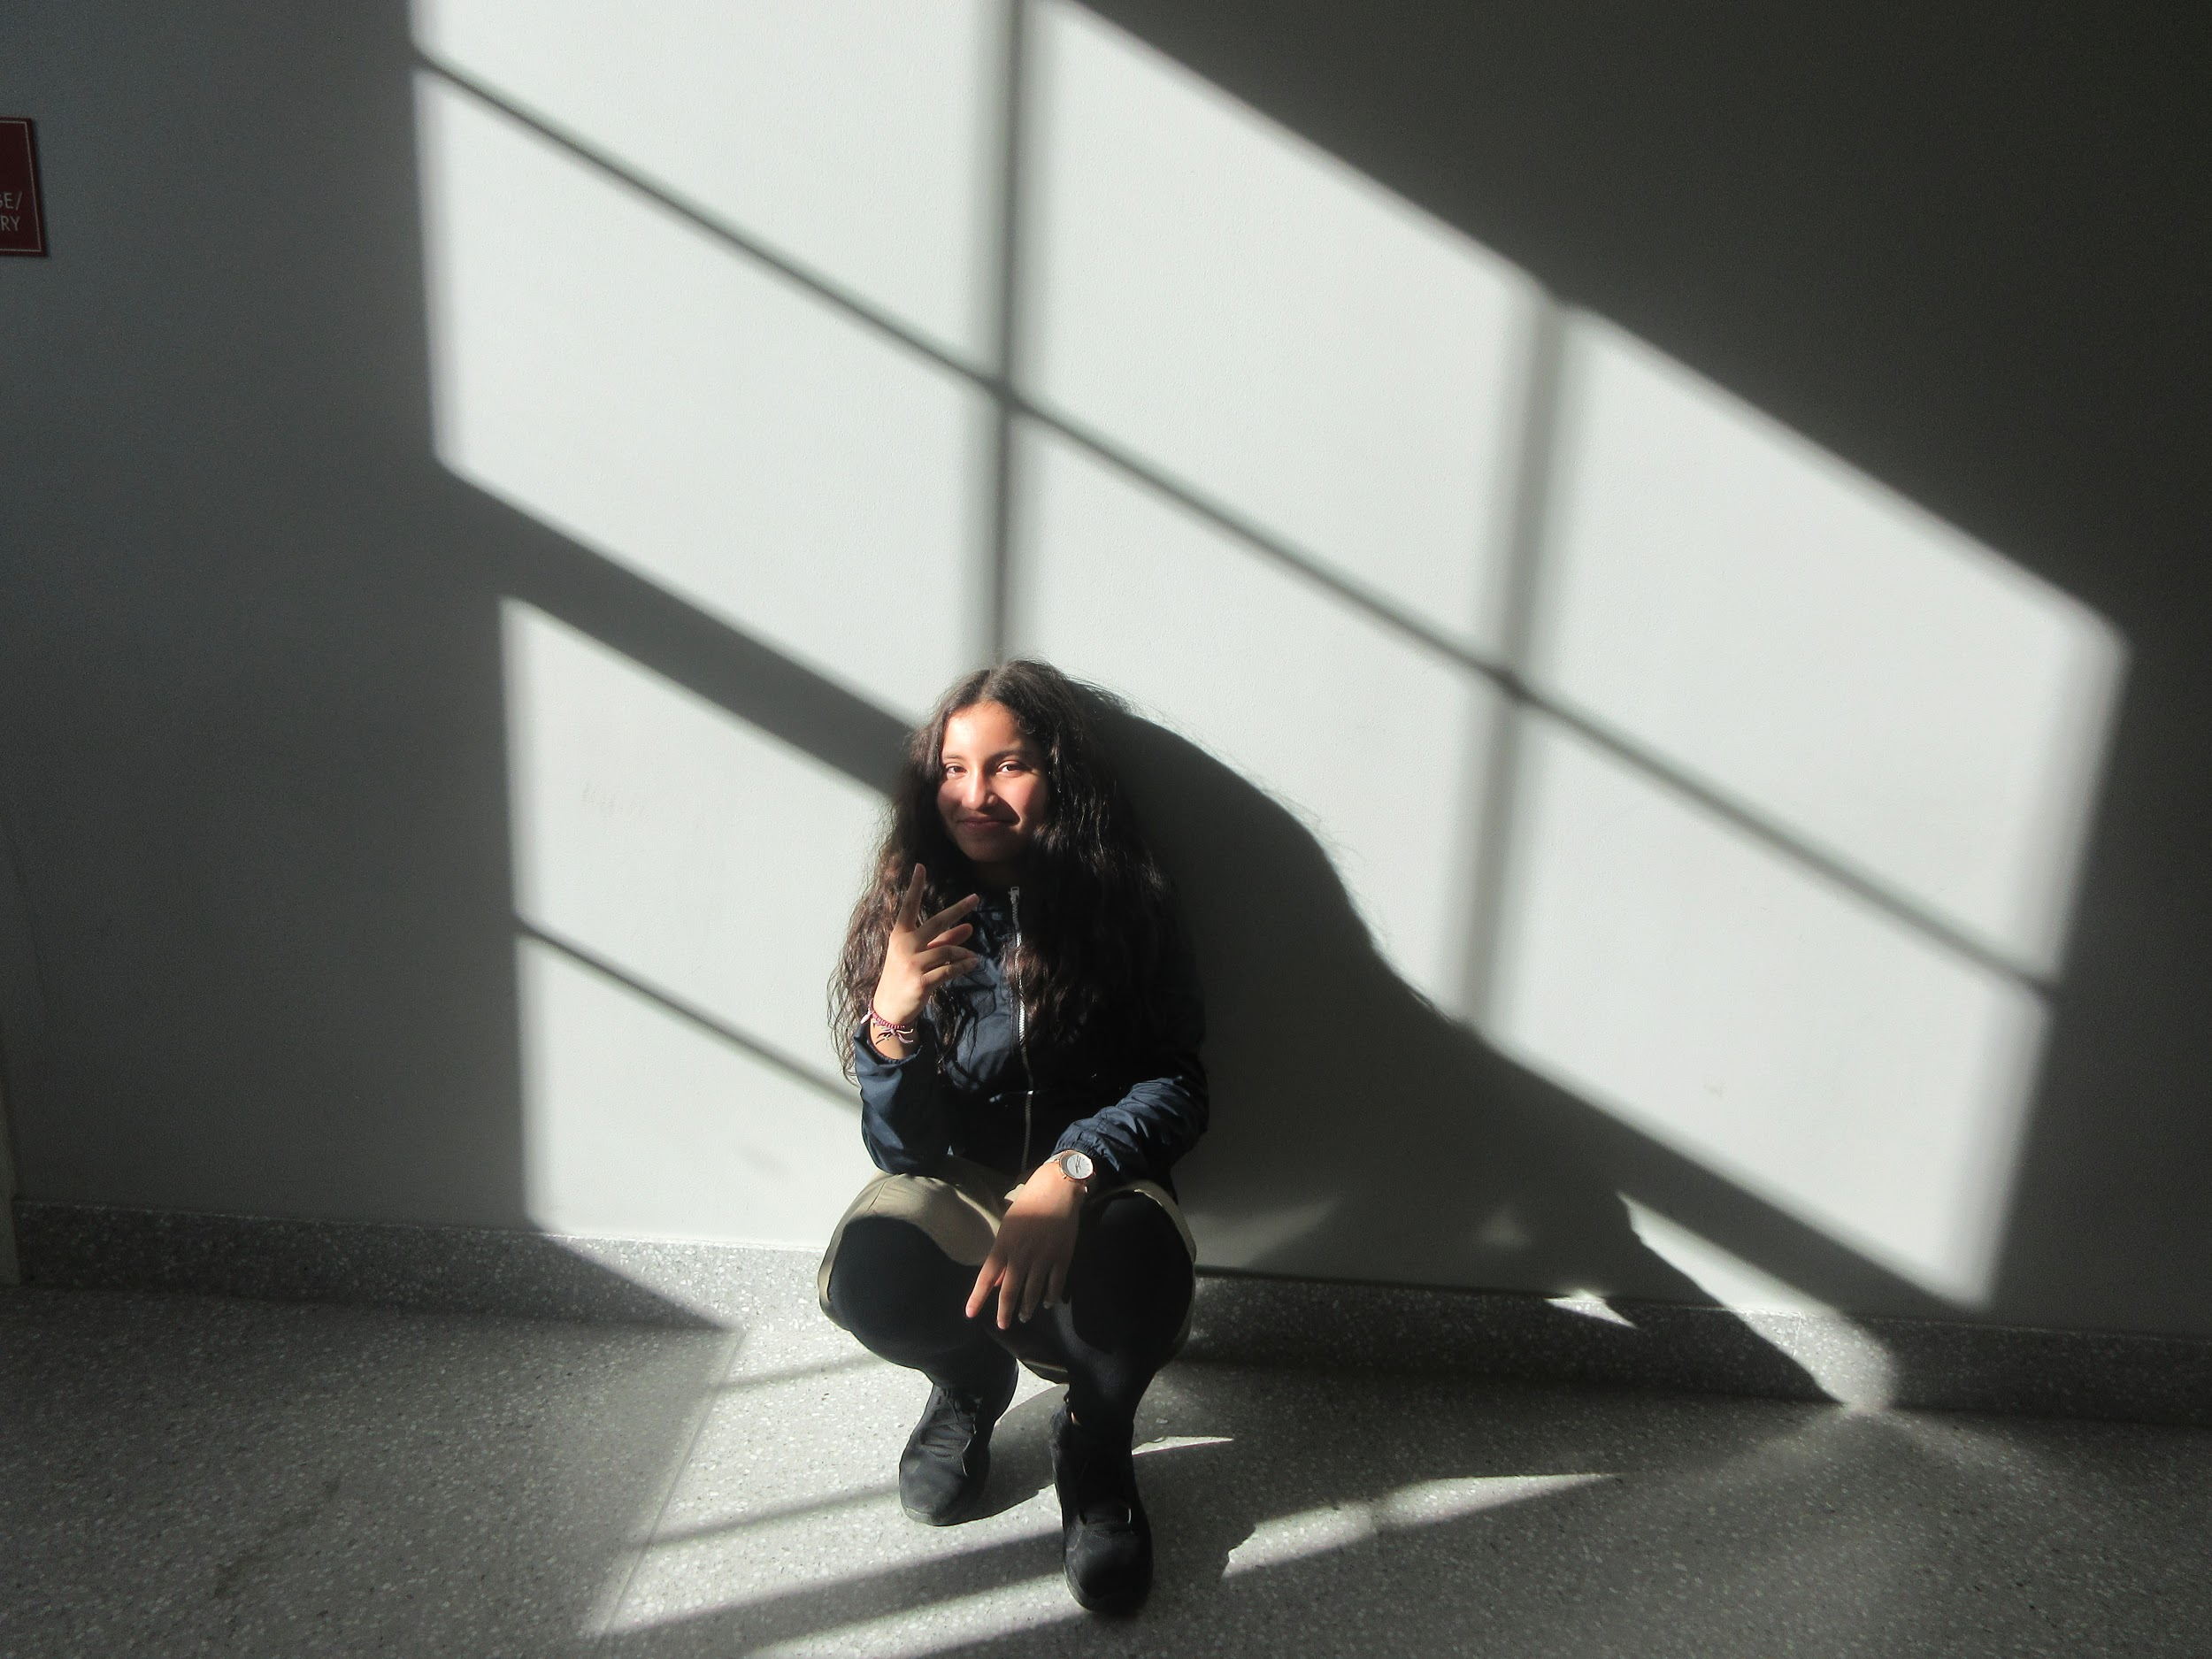

- Kevin Silva-Bueso
Untitled
January 4, 2019
Cardozo Education Campus
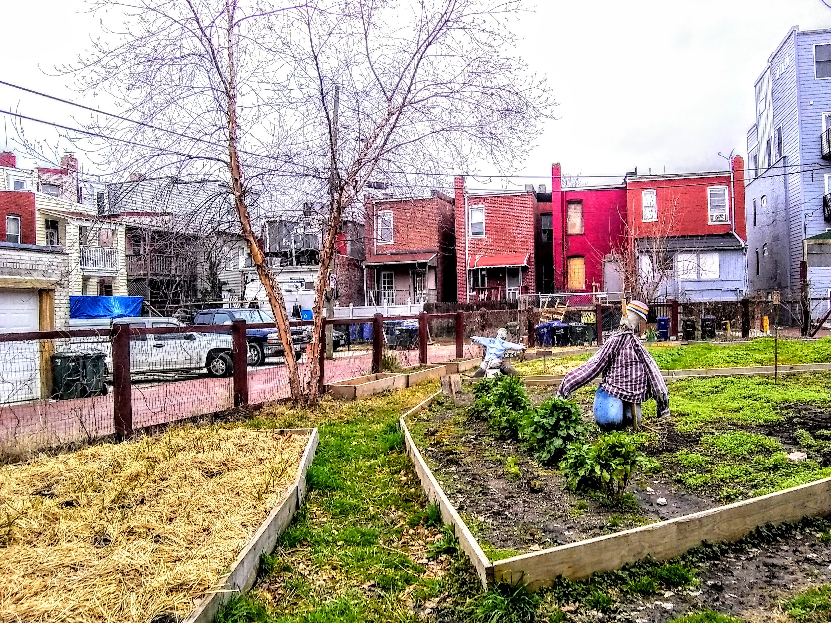

- Taimia Ivey
#Oops
“She wasn’t ready. Still pretty.”
Sousa Middle School
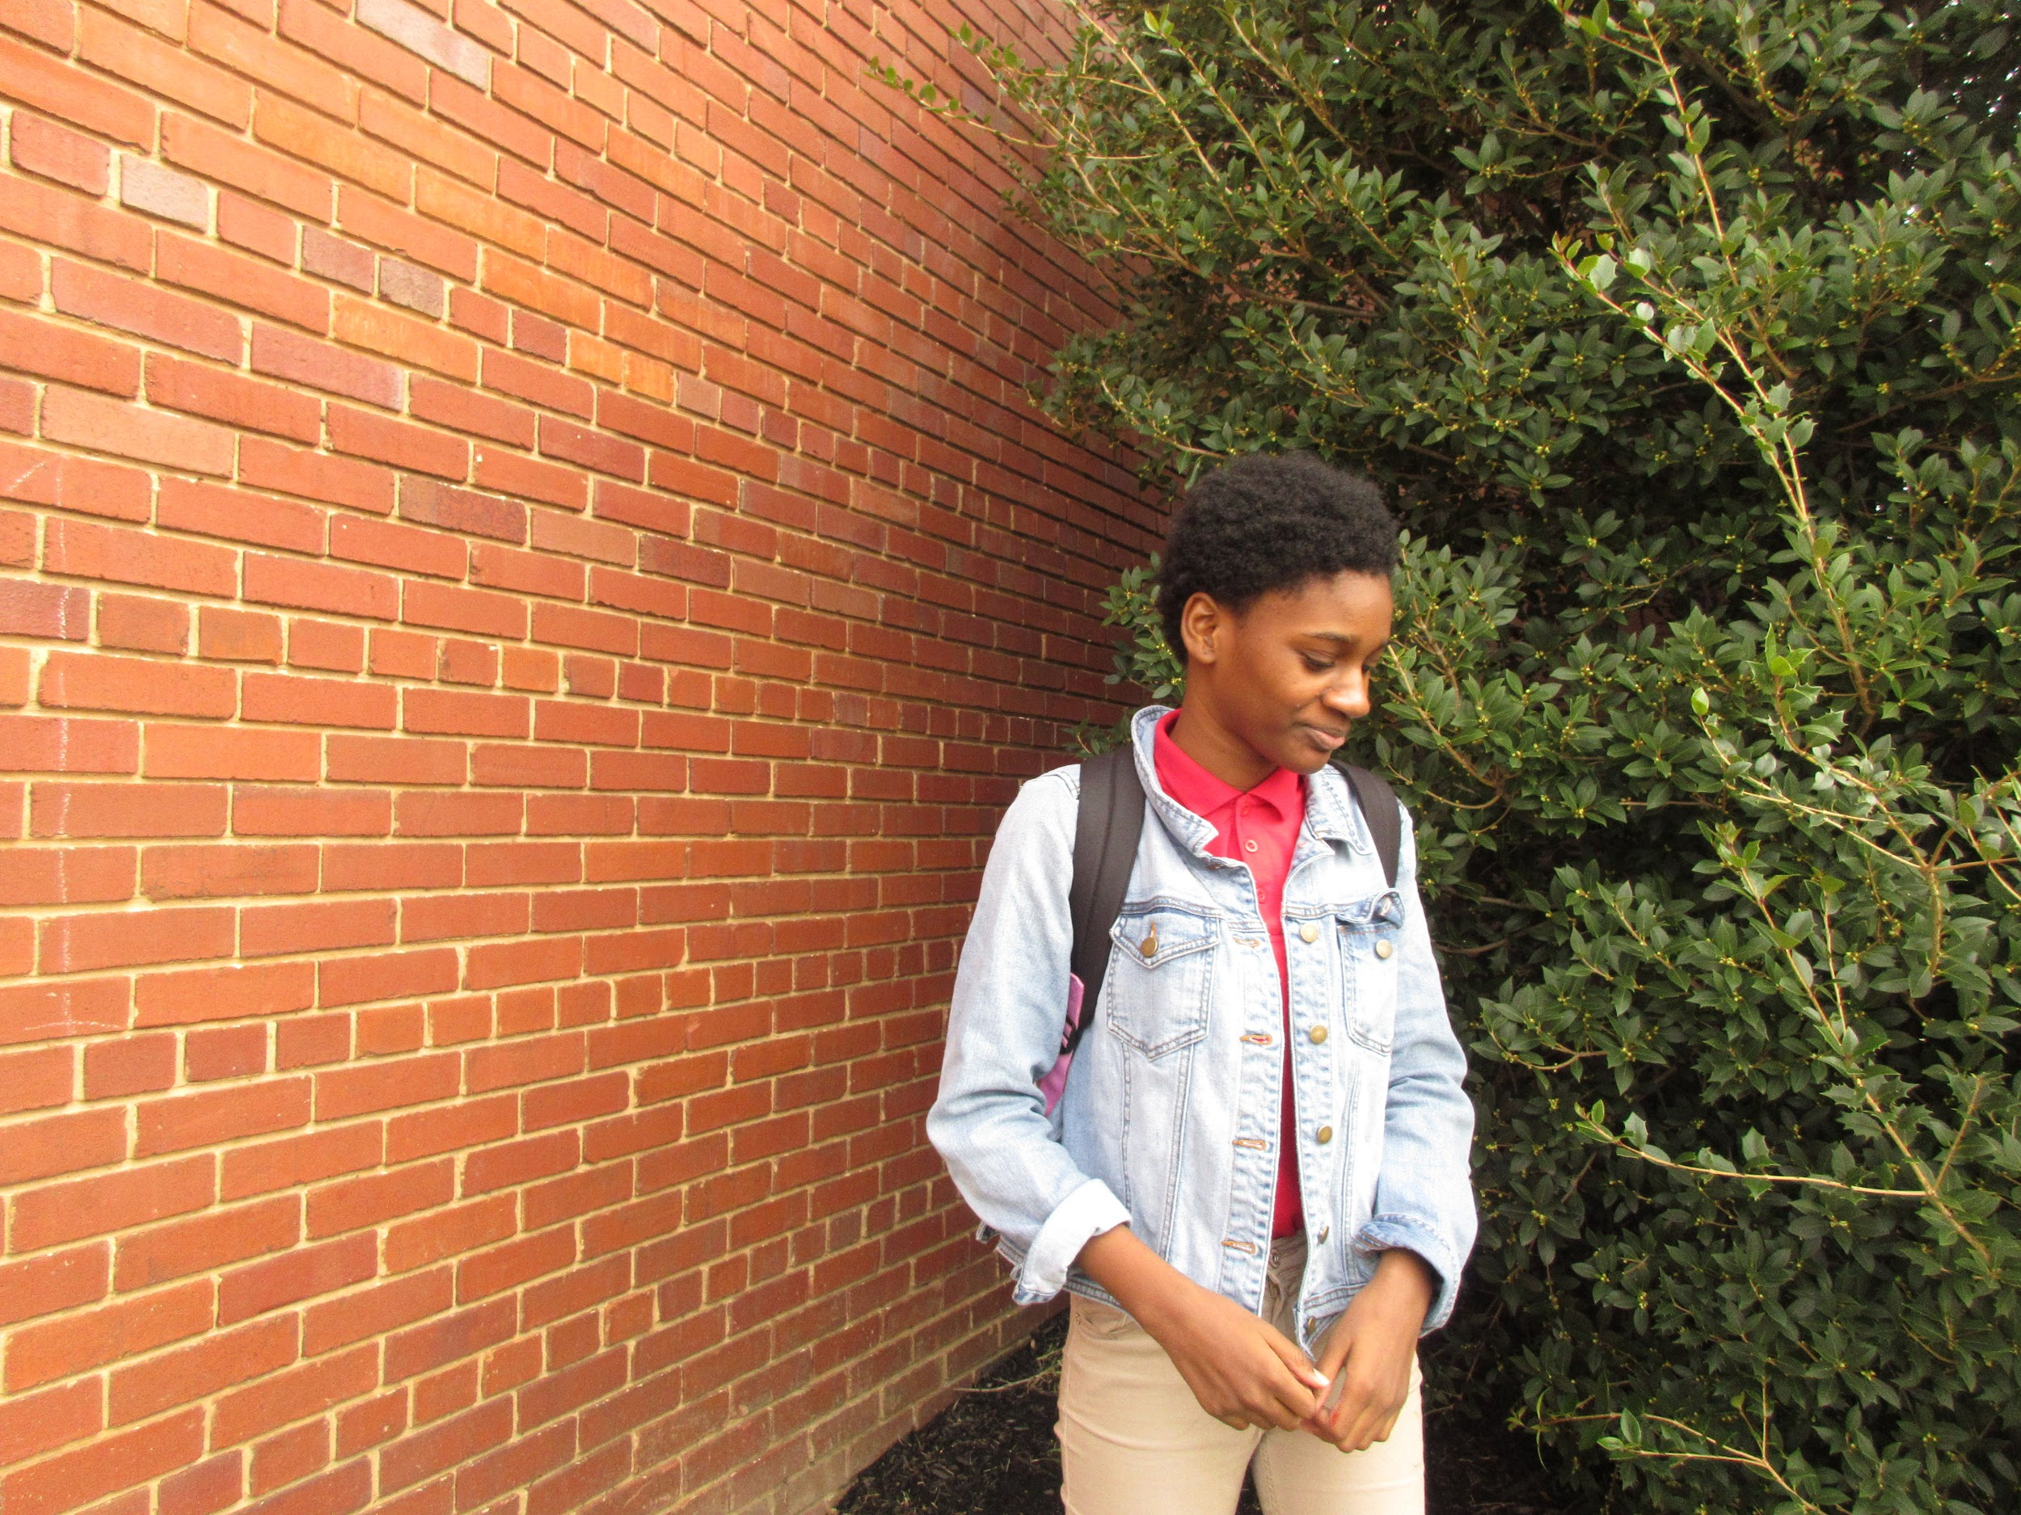

- Justin Scofield
Up in the Sky
“I wanted to show our playground at CHM@L the same way we see it when we play on it everyday. This is the view we see as we climb higher and higher on the equipment.” -November 8, 2018
Capitol Hill Montessori
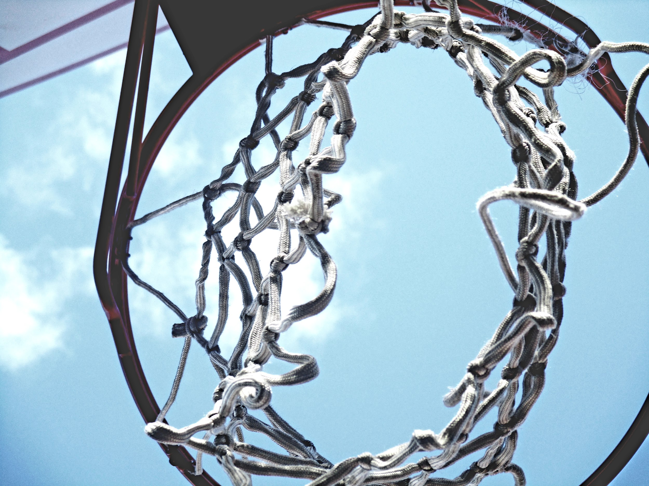

- Laura-Esly Codija
Neighborhood Door
“This is door with a wreath, taken November, 2018. this shows the festive spirit of my neighborhood. despite the stigma with the SouthEast being run down, we still make an effort to make our neighborhood look welcoming and fun! ” November 2018
School Without Walls @ Francis Stevens
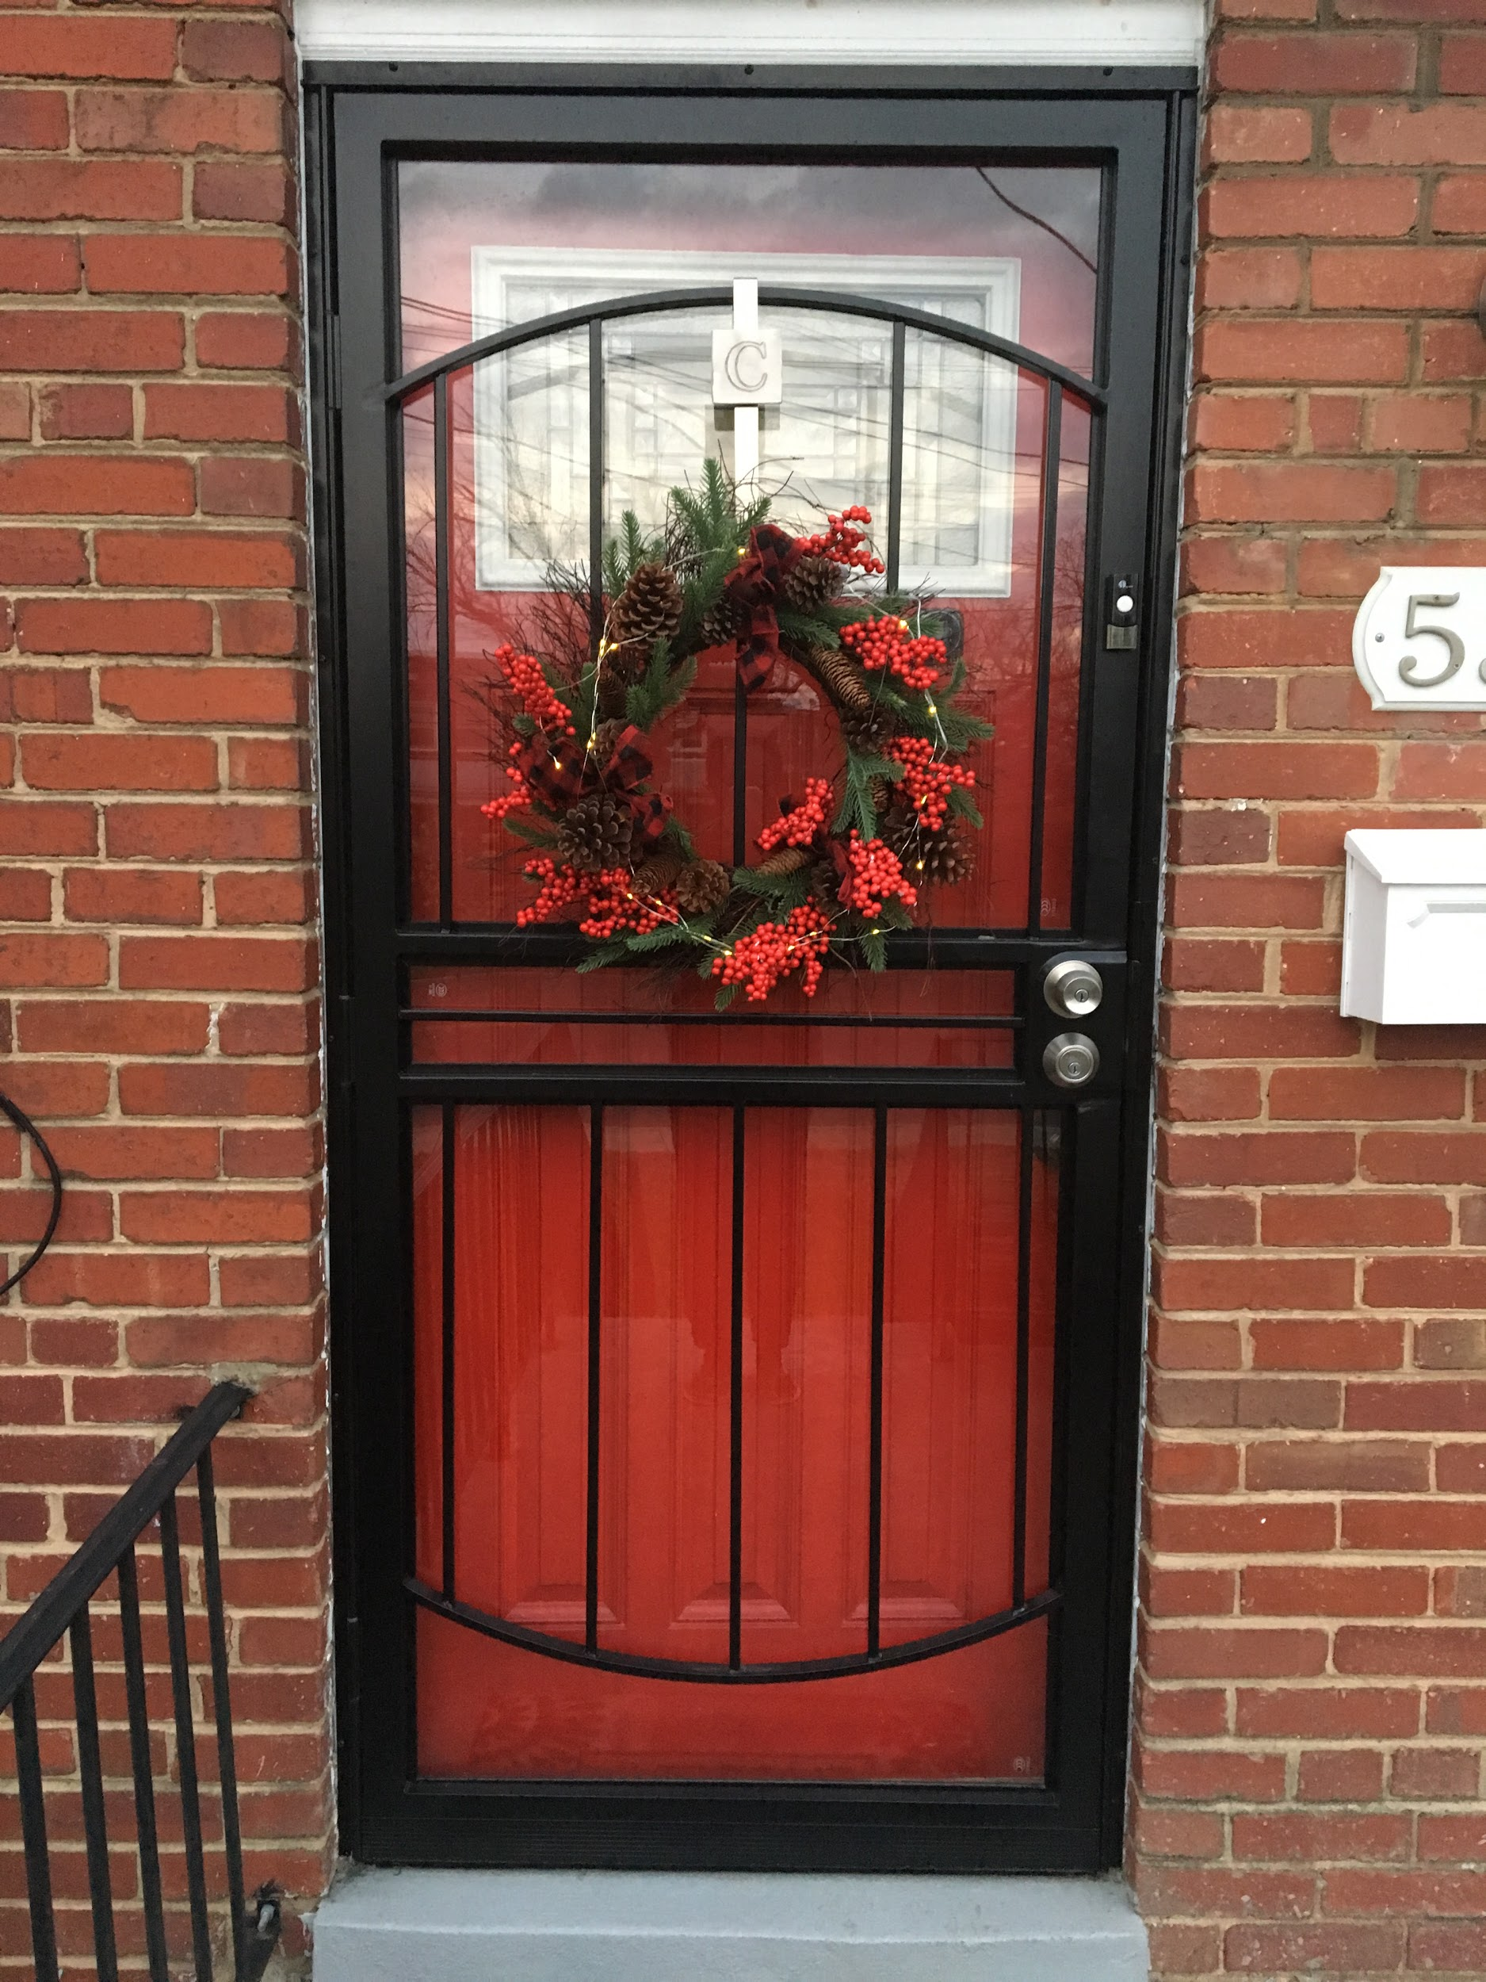

- Saniya Motley and Kristen Murphy
Untitled
“A girl playing on the playground at Whittier. This picture shows how fun Whittier is and how happy people are when they come to Whittier” - January 10, 2019
Whittier Education Campus
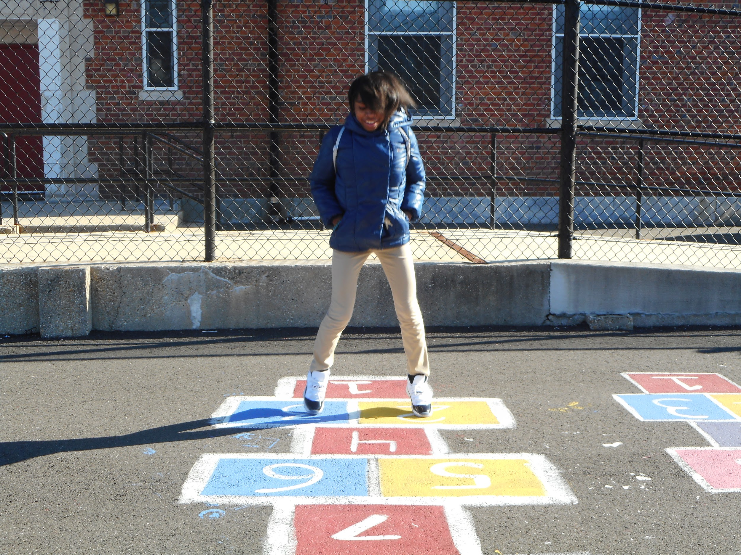

- Nijaia Jenkins
My Eyes Are Watching
“I love to take detail photos because they frame the object you want to focus on. In taking photos of my eye, I see all the details that exist within the eye and the lighting of the camera serves as a reflection.” - October 23, 2018
Kramer Middle School
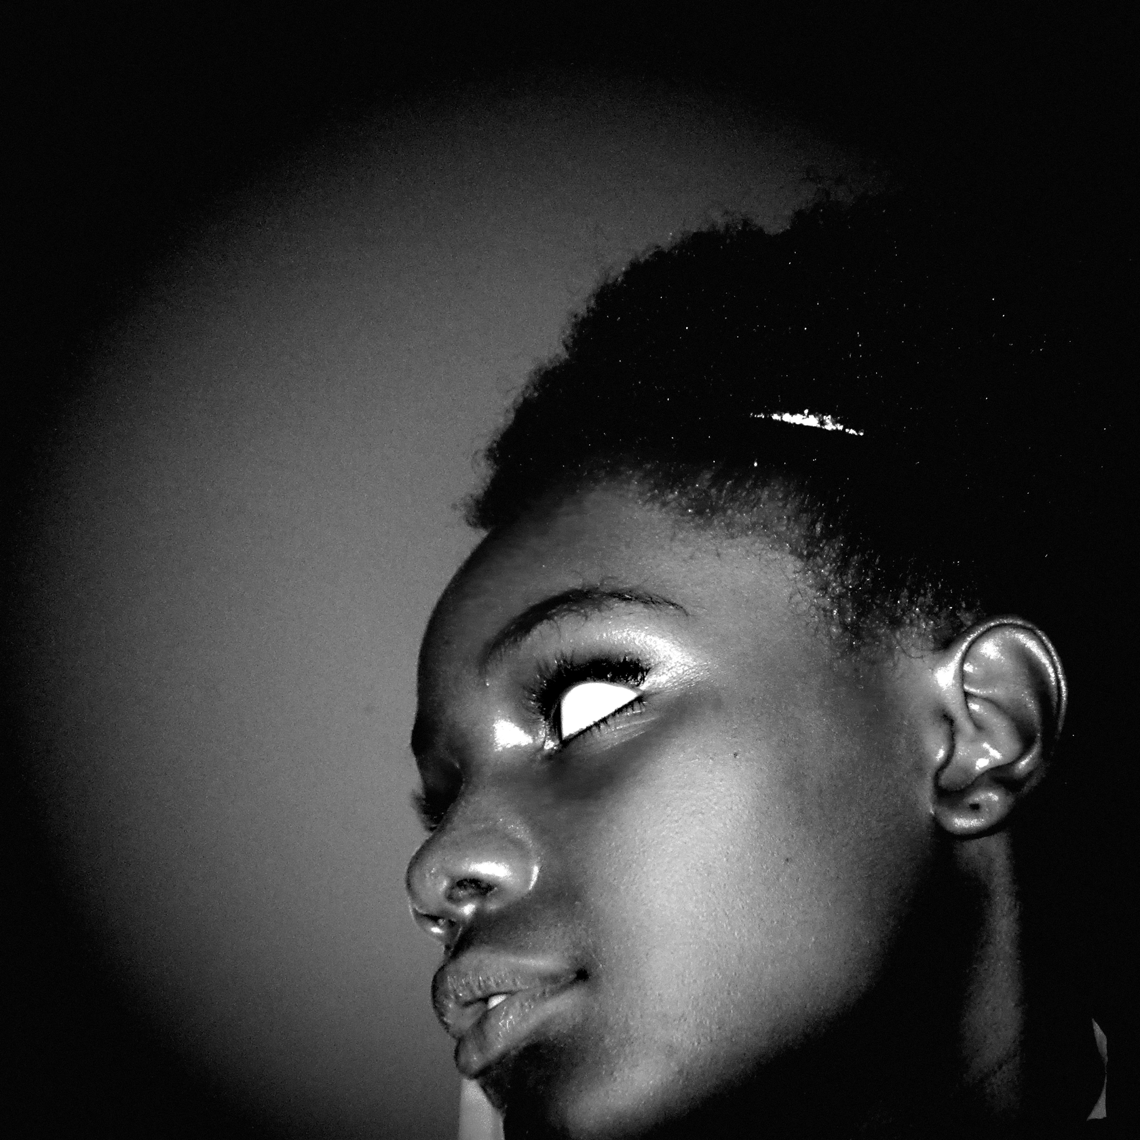

- Jalirah James
“This is a picture of Joiaea and she is sitting on the steps of Hart Middle School. This is my everyday D.C. because it capture a moment of the day at Hart Middle School”-January 25, 2019
Charles Hart Middle School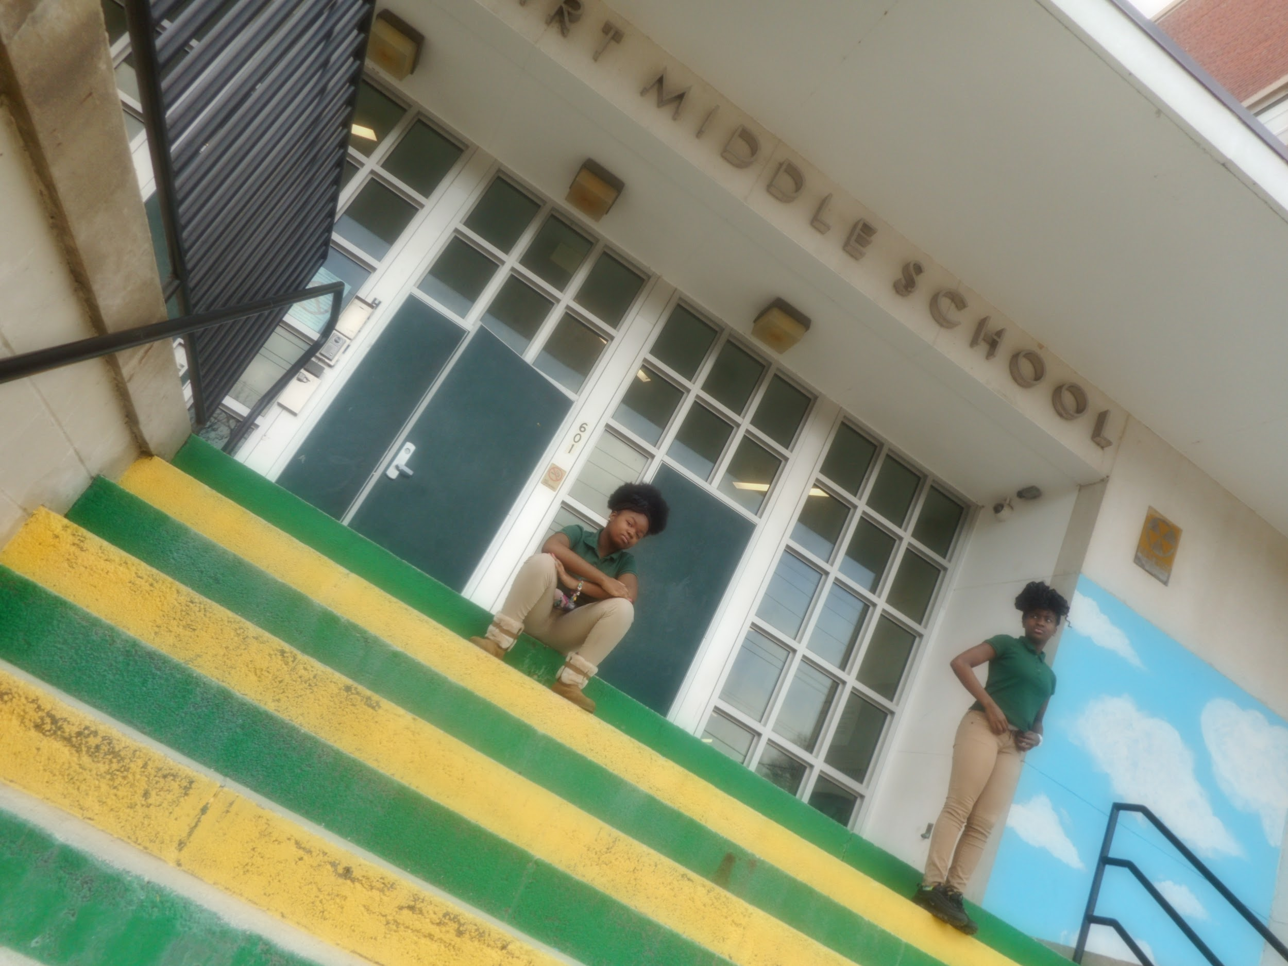

- Keith Petty
Leaping for the weekend
“Friends: Trae-von, Dion & Edward leaping into the weekend in front of JMS.”
January 10, 2019
Johnson Middle School
